ST. THOMAS OF VILLANOVA,
OUR SCHOOL PATRON SAINT
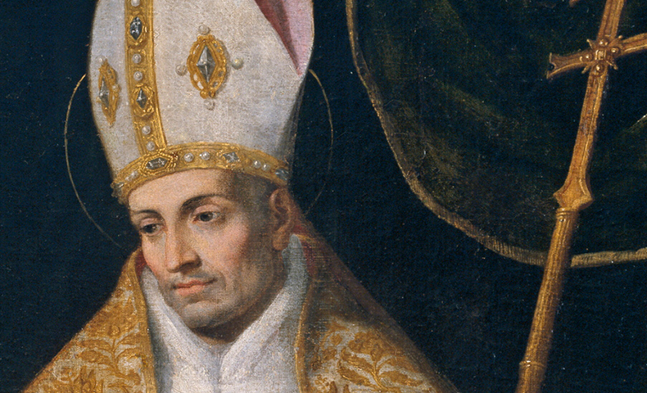
PRAYER OF ST. THOMAS OF VILLANOVA
I will love you, Lord, in every way and without setting limits to my love.
You set no limits to what you have done for me;
You have not measured out your gifts.
I will not measure out my love.
I will love you, Lord, with all my strength, powers, as much as I am able.
In you, O Lord, have I hoped.
Amen

